System Operation
This section reproduces the Timme Lab CLiQR protocol document, including detailed instructions about system operation.
Note: This protocol is for the lickometry system designed and implemented in Spring 2025 (protocol last updated 9 February 2026). The system consists of a Dell Supermicro desktop PC running the CLiQR GUI (https://github.com/timmelab/cliqr) to communicate with MPR121 capacitive touch sensors (with communication facilitated by FT232H boards). Each pair of FT232H+MPR121 can record from 6 cages, for a total of 24 cages currently (with 4 pairs of boards).

Equipment/Reagents
- 24 Sipper Holders (should be attached to the system already)
- 24 Graduated Sippers (with rubber stoppers)
- Dell Supermicro Desktop
  - As mentioned in the note above
  - Already attached to the rack
- Scale + Beaker
  - For recording animal weights
  - If the animals had their weights previously recorded the same day (e.g. before forced swim testing in the morning), you can simply record those weights in the UI and skip the scale+beaker
- Phone/timer
  - The system will record continuously until stopped, so you’ll want something to time the run
- 1 L of 20% Ethanol (210 mL of ethanol per 790 mL of water, since we have 95% ethanol)

Starting a Session
- The first step should be filling the graduated sippers with 20% ethanol solution so that it’s easier to quickly start the animals drinking in sequence (without long gaps between start times).
  - Fill the sippers with ~10 mL and ensure that the rubber stoppers are firmly inserted.
  - Filling should be done with a finger or palm covering the tip of the sipper, because the liquid will quickly leak out otherwise.
  - Once the rubber stopper is inserted, ensure that the sipper is not leaking excessively by uncovering the tip while holding the sipper over a sink or the drain in the floor.
  - If the sipper leaks (more than 1 or 2 drops), double check the stopper. If that doesn’t solve the issue, set that sipper aside.
- Power on the computer (if necessary) and log in to the TimmeLab account (or whatever account your lab has created for the purpose!)
- Double-click on the desktop shortcut with the name “CLiQR” and the recording interface should display after a few seconds
- At this point, your screen should look roughly like Figure S18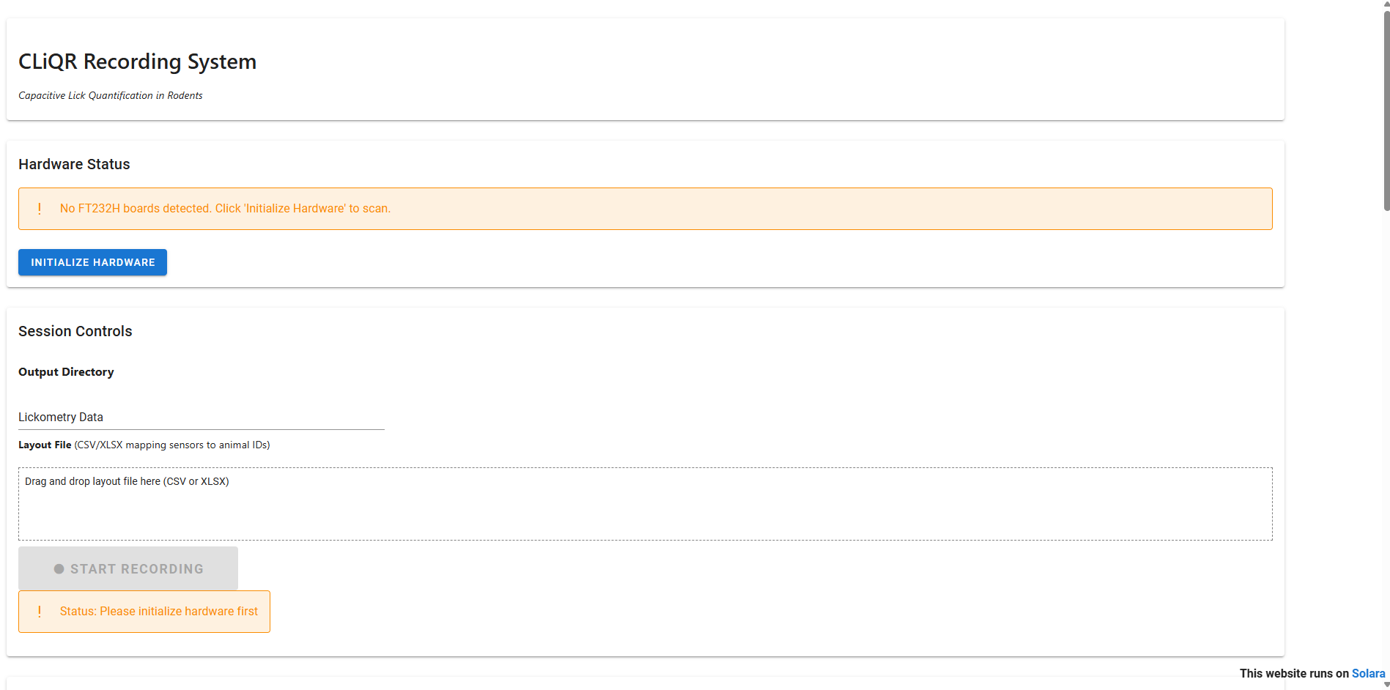
Figure S18. Initial CLiQR GUI Window Appearance
- Begin by pressing the “Initialize Hardware” button, and the system will detect and configure all of the capacitive sensors. The resulting window should look like Figure S19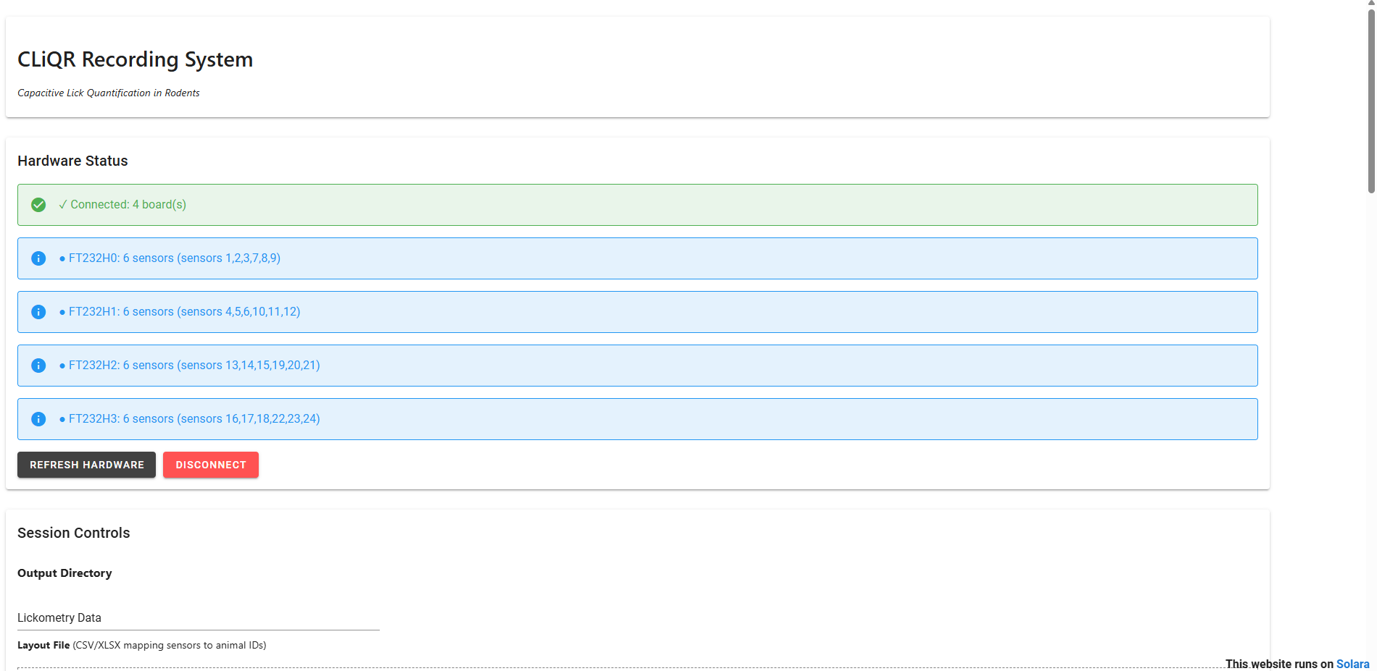
Figure S19. CLiQR GUI after hardware initialization. Notice that all 4 FT232H boards are listed, along with the sensors each controls.
- The “Output Directory” text entry box defaults to “Lickometry Data” (a subdirectory inside the CLiQR directory, just for storing data recordings)
  - This can be changed to include the cohort identifier, like “Lickometry Data/AEW6”, which will create a subdirectory for that cohort inside of the lickometry data subdir.
- The “Layout File” section is for assigning animals to sensors so that it stays consistent between drinking sessions. On the first session of a cohort, this will need to be created (and it will be reused each day).
  - This can be created in Excel or just a text editor.
  - The format should be sensor_number, animal_id and each sensor should be on a new line.
  - For instance, 1,AEW6-1 shows the animal ID on sensor 1.
  - Ensure the file is saved as csv and drag-and-drop it onto the cage layout upload box in the CLiQR GUI.
  - The resulting screen should look like Figure S20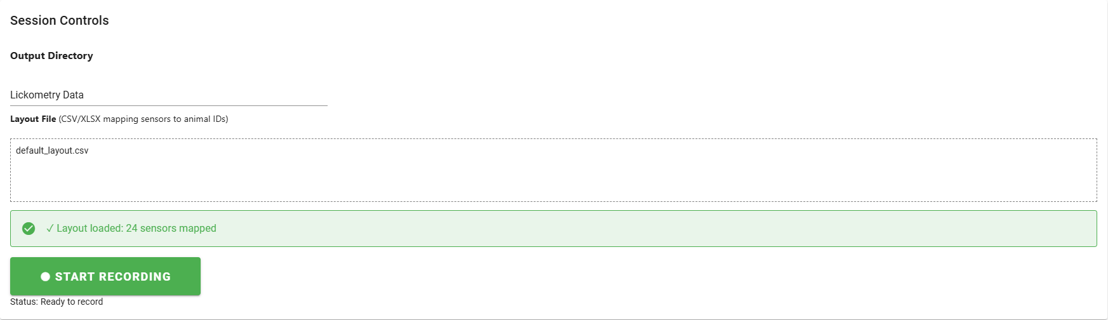
Figure S20. Layout file upload confirmation.
- If not already done earlier in the day, weigh each animal using the scale and beaker
- Record the animal weights (whether directly measured just now, or from the data sheet with animal weights from earlier) in the “Weight” input box corresponding to the correct sensor for each animal.
  - Now, you should place the animal cages on the rack (6 cages per shelf). The sensors are numbered 1-6 (top shelf, left to right), 7-12 (2nd shelf), 13-18 (3rd shelf), 19-24 (bottom shelf). The recording interface matches this layout as though you are standing in front of the rack looking at it.
  - You will need to move the sipper holder (Figure S21) out of the way before placing the cage on the rack
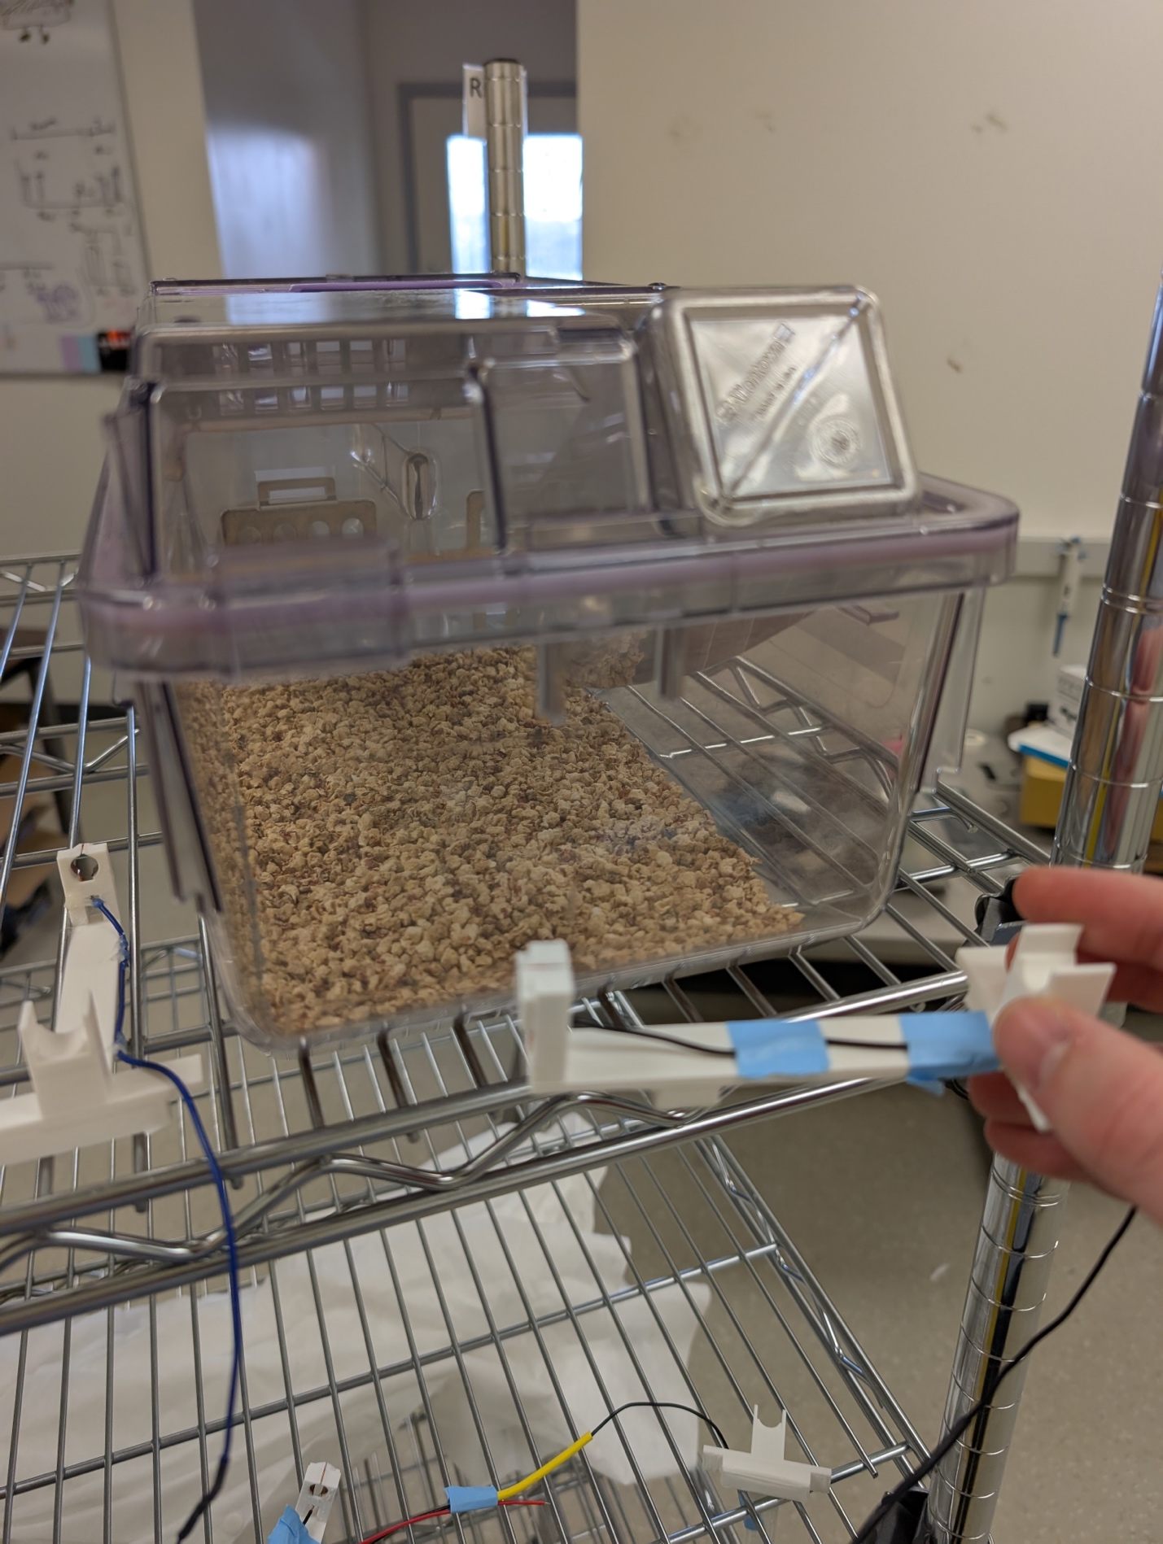
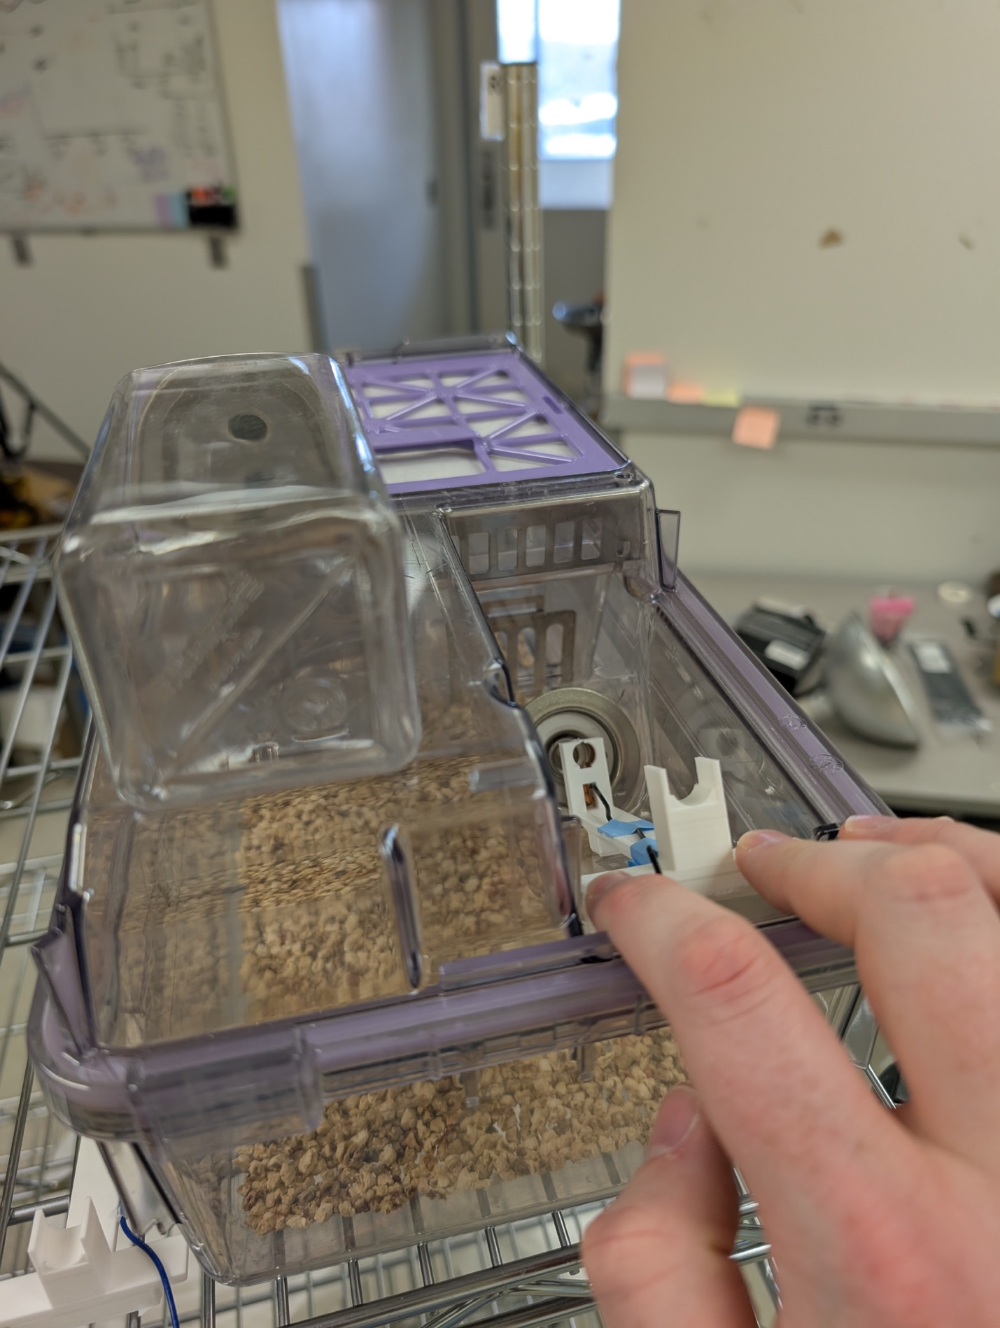
  - Once you have placed the cage on the rack, move the large water sipper out of the way (it can be placed on top of the cage lid as shown in Figures S22). Now, place the sipper holder on the cage lid (Figure S22).
Figure S21. Move the sipper holder out of the way and place the cage on the rack.
Figure S22. Place the sipper holder on the cage, moving the large water sipper out of the way.
  - Ensure that you have placed the correct sipper holder by checking that the number written on tape wrapped around the attached wires matches the sensor number for that animal
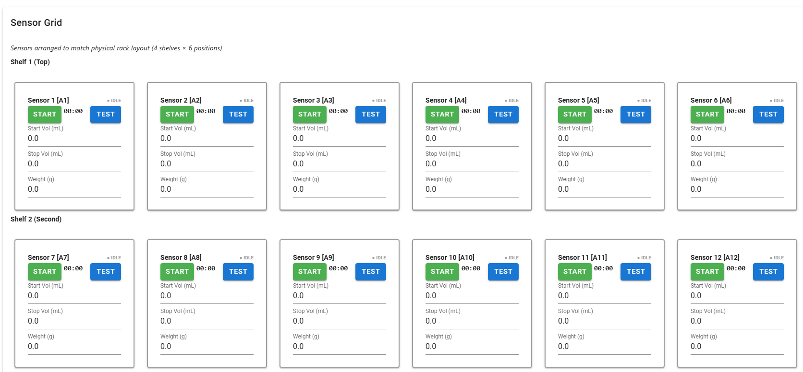
- Once the cages are situated, press the “Start Recording” button. The sensor grid will change to look like Figure S23 (note the colored start and test buttons).
Figure S23. Sensor grid while recording, note the colored buttons (the buttons are greyed out when not recording).
- Starting with sensor 1, place the sippers in the holders one at a time while testing that the signal is good and recording volumes
  - Insert the sipper tip through the ring on the sipper holder and the metal opening on the cage lid (Figure S24)
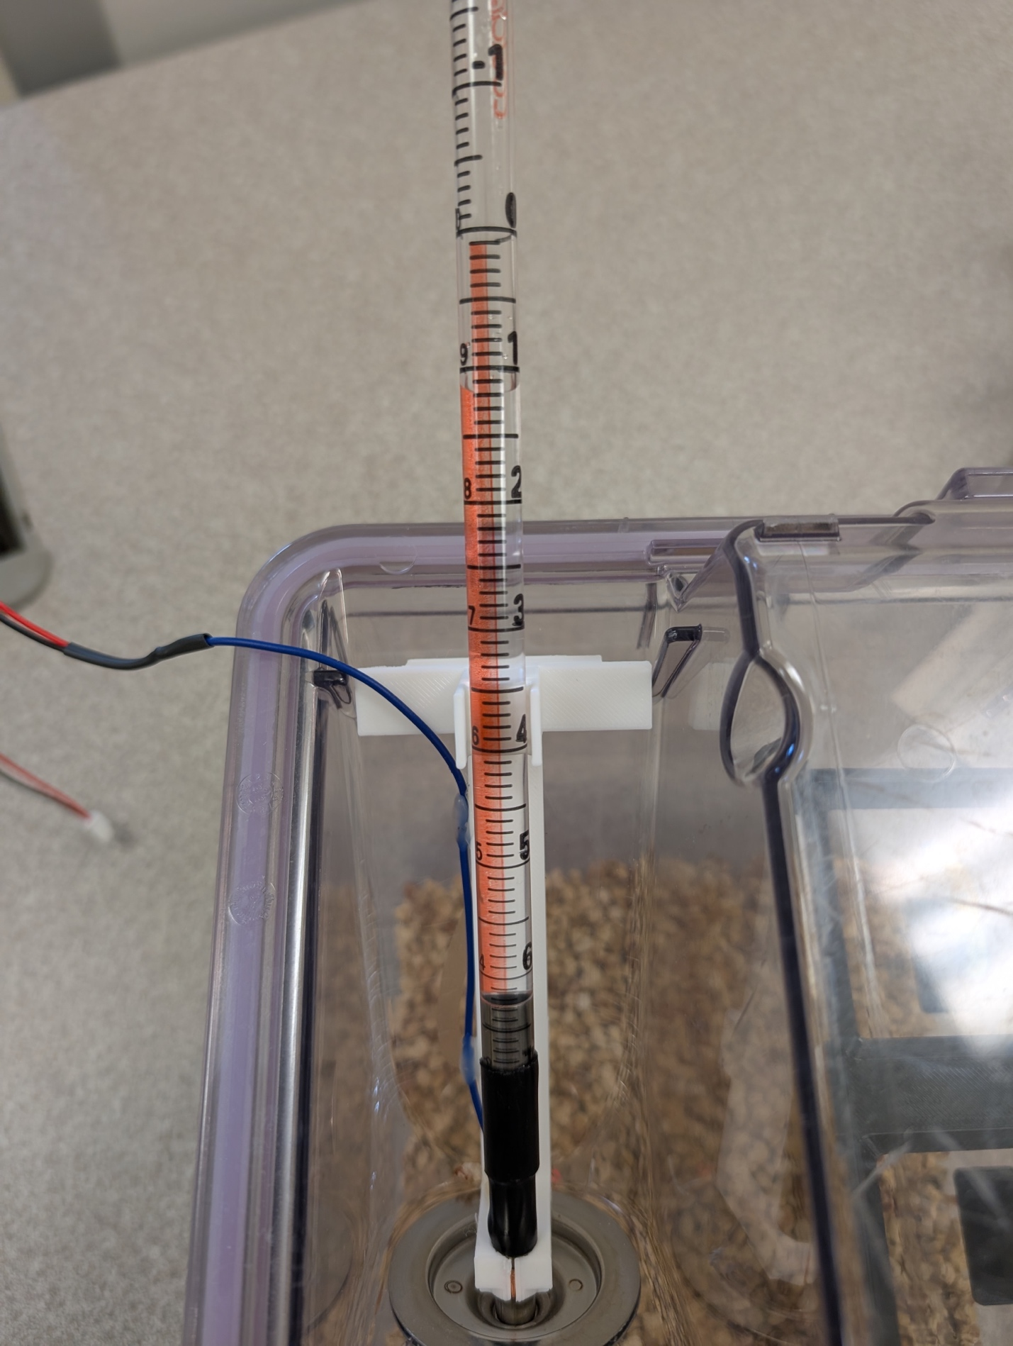
Figure S24. Sipper inserted through sipper holder ring and cage lid.
  - Test the signal
    - Three firm presses with an ungloved finger on the metal ring through which we push the sipper
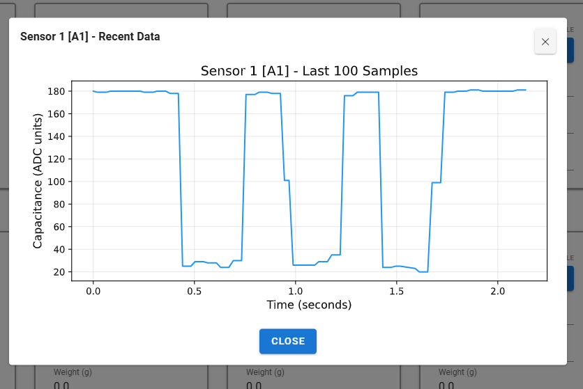
    - Wait a second (for the data to be saved), then press the “Test” button next to the sensor you’re testing in the UI (Figure S25)
Figure S25. This is an example of a good test that shows a strong signal. We expect a drop greater than 100 pF from each finger press
    - The signal should start at or above 165 pF and drop to 80 pF or lower
    - You should be able to clearly distinguish all three finger presses
    - If the signal isn’t good, there are a couple of things to try:
      - Adjust the sipper holder to ensure that the copper tape is making firm contact with the ring
      - Use a small amount of alcohol to wipe the copper tape and metal ring (dirtiness can degrade the signal)
      - If you cannot get the signal to look good through fiddling, make a note of which sensor/animal in the comments box at the bottom of the CLiQR GUI and move on
  - Press the “Start” button corresponding to the sensor you just tested
  - Record the sipper volume in the “Start Vol” input box. See Figure S26. The volume should be read by the same person each time, both when starting and stopping a run, to minimize inter-person variability of readings. The sippers should typically be filled to around 10 mL, but the change in volume between starting and stopping volumes is much more important than the absolute starting point (a start reading of 2 mL and stop at 1.9 mL will give the same results as a start at 10 mL and stop at 9.9 mL in our analysis).
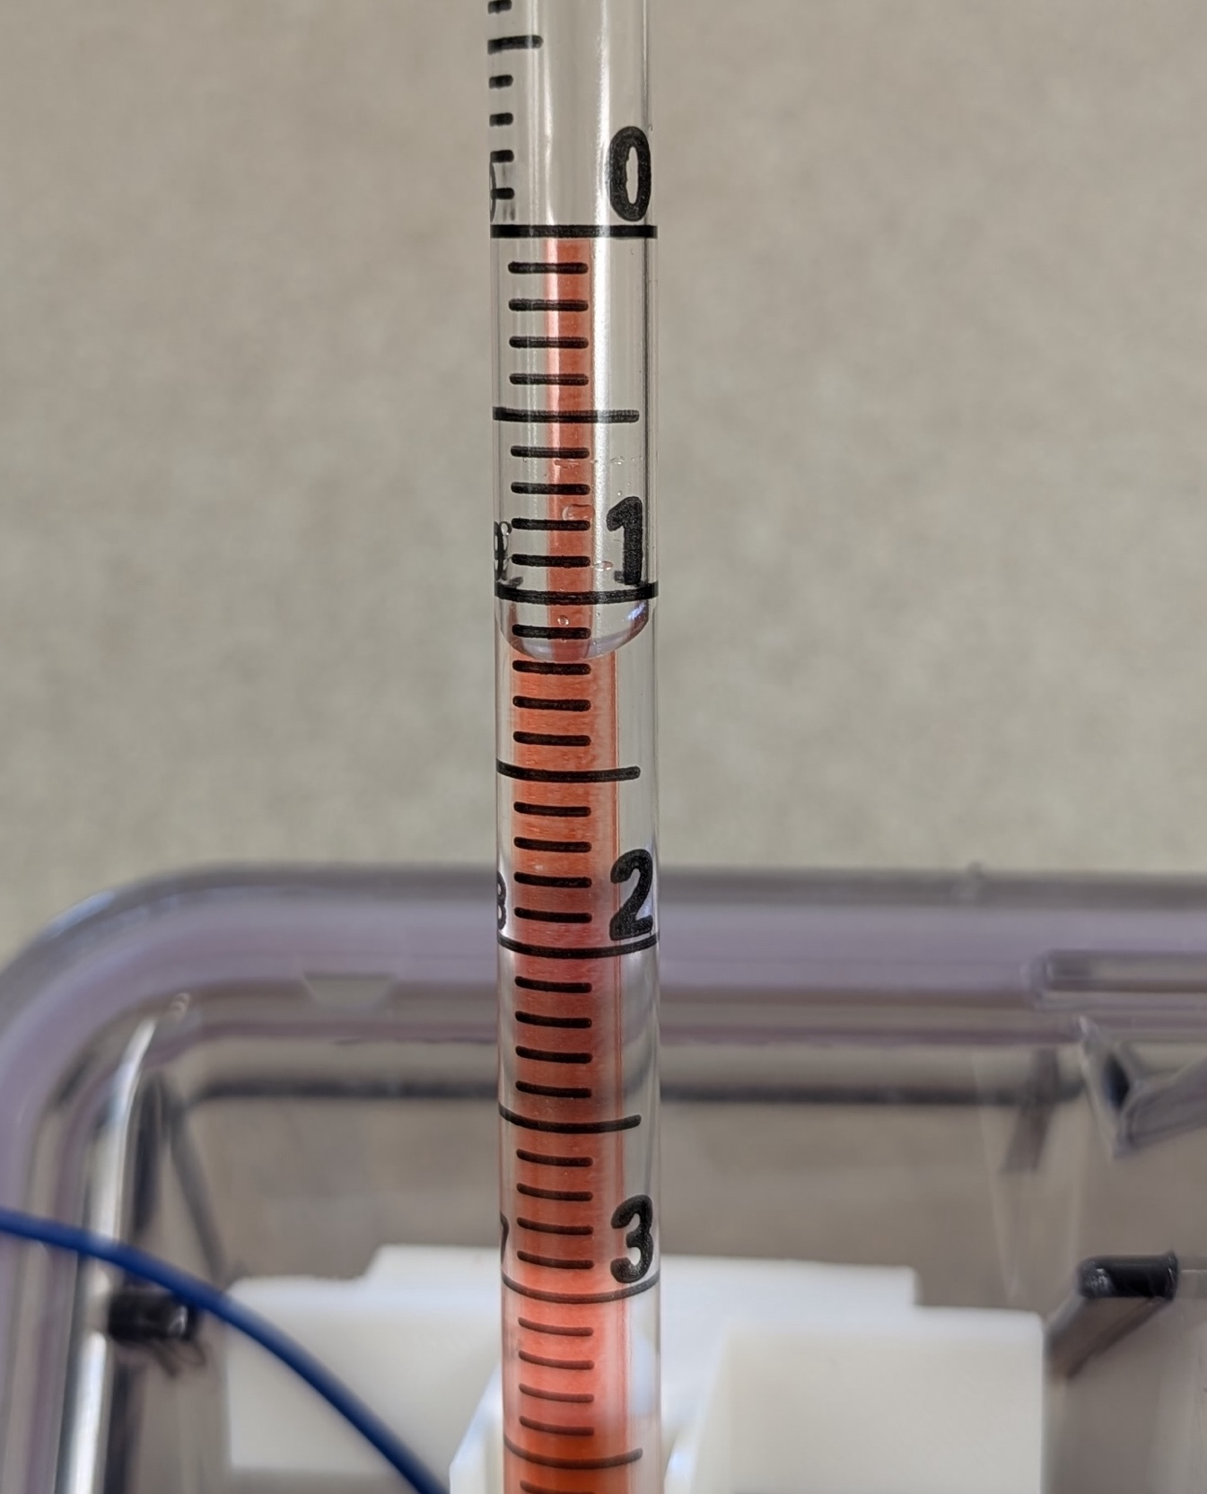
Figure S26. This sipper would be read as 8.8 mL. It’s difficult to see here, but there are alternative labels: 0 = 10, 1 = 9, 2 = 8, etc. So we read this as 1.2 mL below 10 = 8.8 mL.
- Once you have completed the above steps, set a timer for 2 hours
- Place the “Experiment in Progress” sign on the rack

Ending a Session
- Wait outside vivarium until the 2 hours are complete
- Take “Experiment in Progress” sign down
- Starting with sensor 1 again:
  - Press the “Stop” button corresponding to the correct sensor
  - Read and record the volume of liquid remaining in the sipper in the “Stop Vol” input box
  - Carefully remove the sipper from the sipper holder and set aside
  - Remove the sipper holder from the cage lid and place it on the rack beside the cage
  - Replace the large water bottle
  - Transfer the cage back to the other rack
- Once you’ve stopped the sensors, press the large “Stop Recording” button to finalize the data files
- The data has been saved in the directory you selected for the “Output Directory”, which defaults to C:\Users\TimmeLab\CLiQR\Lickometry Data\
  - raw_data_{date of recording}.h5
  - Copy the data file to the lab drive (L:\). The specific directory will depend on the current experiment. If you’re unsure, please ask!
  - You can leave the files on the rack computer also, so that we have multiple copies (just in case)
- Close the browser window and the PowerShell window (should be running behind the browser), then put the computer to sleep
- Dump out the remaining fluid from the sippers

Note!
If there are any issues during operation of the system, please write a note about the issues in the “Comments” box found at the very bottom of the GUI window. See Figure S27.
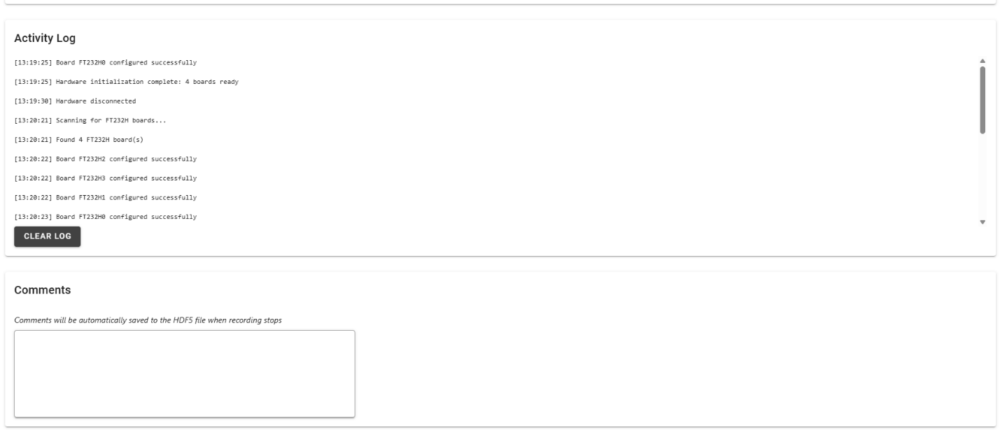
Figure S27. Activity log (for debugging) and comments section are found at the very bottom of the CLiQR GUI window.

